Sunday 26th April Easter 3
A thought on today’s Gospel Reading ~ Luke 24. 13-35

The Emmaus road story is so amazing, Jesus was there and they didn’t know. Maybe we’re feeling like that at the moment; alone, frightened, lonely...and maybe we’re finding it hard to reach God and draw him close. In this story though, there is hope, there is recognition, there is drawing close. And maybe the reflection which follows, it might allow you to glimpse this story anew and find the hope and peace which only God can give.

All through life’s day,
you walk with us Lord.
But often we don’t recognise you,
for we are blinded by work and worry,
doubt, confusion and fear,
and so you remain a stranger to us.

Before the day’s end we will ask many questions,
experience many sorrows and disappointments,
and then, suddenly,
whether we are young, middle-aged or old,
we will find that night is falling.

In that moment we pray,
that like the disciples on the road to Emmaus,
our eyes will be opened and that we will recognise you.

And you will not vanish from our sight,
but stay with us,
to guide us to the Father’s house.
Author unknown

Why not re-read today’s gospel account and who knows what God might shw you.
‘Jesus, took bread, blessed it and broke it, and gave it to them. Their eyes were opened and the recognised their Lord....’
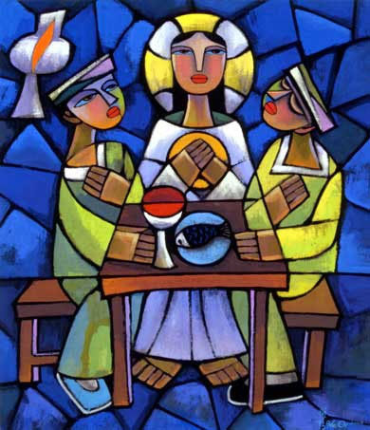
Supper at Emmaus Source: http://diglib.library.vanderbilt.edu/act-imagelink.pl?RC=46124 Artist: Dr. He Qi

Easter Blessings & love
Revd Tonya

